Instructions for the preparation of a manuscript

Author One,1*

1School of Electrical and Electronic Engineering, Nanyang Technological University, 50 Nanyang Avenue, 639798, Singapore

[*email](mailto:*opex@osa.org) address

**Abstract:** Updated 14 June 2017. Explicit and detailed rules are given for preparing a manuscript for OSA express journals. After a general introduction and a summary of the basic requirements, specific guidelines are given for all major manuscript elements (such as abstract, headings, figures, tables, and references) to achieve optimal typographic quality. The use of complete and properly formatted references is particularly important. Adherence to these guidelines will significantly expedite the production of your paper.

1. Introduction

Adherence to the specifications listed in this style guide is essential for efficient review and publication of submissions.

OSA accepts Word and LaTeX submissions. OSA will not publish the same Word file that authors submit for their final revisions, so it is imperative that authors carefully check the final version of their paper before paying the publication fee. OSA uses a Word plug-in to normalize, format, tag, update citations, and parse the file into full-text XML.

1. Figures, supplementary materials, and tables

2.1 Figures

Figures should be included directly in the document. All photographs must be in digital form and placed appropriately in the electronic document. All illustrations must be numbered consecutively (i.e., not by section) with Arabic numbers. The size of a figure should be commensurate with the amount and value of the information conveyed by the figure.

All figure captions should be centered beneath the figure. Longer figure captions should be centered beneath the figure and alignment double (left and right) justified, but are not to exceed the left and right edge of the figure by more than 0.5 in. The abbreviation “Fig.” for figure should appear first followed by the figure number and a period. Captions should be in 8- pt. font. At least one line of space should be left before the figure and after the caption.

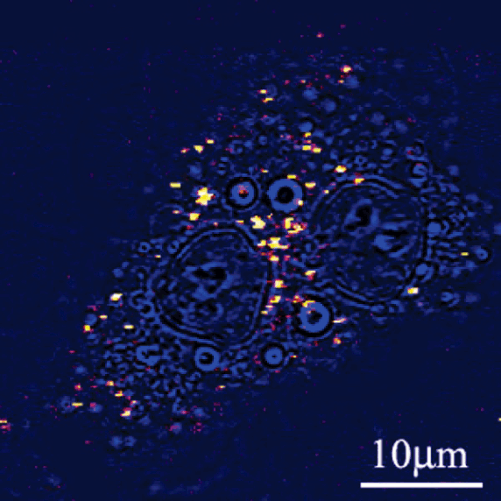

Fig. 1. Sample caption (Ref. [4], Fig. 2).

2.2 Tables

Tables should be centered and numbered consecutively. Authors must use Word’s Table editor to insert tables. Authors must not import tables from Excel. All content for each table should be in a single Word table (do not split content for a single table across multiple Word tables). Tables should use horizontal lines to delimit the top and bottom of the table and column headings. Detailed explanations or table footnotes should be typed directly beneath the table, but not in a table cell. Table footnote labels should be alphabetical; numbers or special characters are not permitted. Position tables as closely as possible to where they are mentioned in the main text.

Table 2. Optical Constants of Thin Films of Materials*a*

|  |  |  |  |  |  |
| --- | --- | --- | --- | --- | --- |
|  | 83.4 nm | |  | 121.6 nm | |
| Material | n | K |  | n | k |
| Ir | 1.182 | 0.865 |  | 1.450 | 1.040 |
| MgF2 | 1.584 | 0.487 |  | 1.682 | 0.0627 |
| Al | 0.09874 | 0.1915 |  | 0.0424 | 1.137 |
| Mo | 0.98 | 1.08 |  | 0.78 | 1.03 |
| C | 1.16 | 1.29 |  | 1.85 | 1.10 |

*a*From Appl. Opt. **40**, 1128 (2001).

1. Summary

Conforming to the specifications listed above is of critical importance to the speedy publication of a manuscript.

**References**

1. K. Gallo and G. Assanto, “All-optical diode based on second-harmonic generation in an asymmetric waveguide,” J. Opt. Soc. Am. B 16(2), 267–269 (1999).
2. B. R. Masters, “Three-dimensional microscopic tomographic imagings of the cataract in a human lens in vivo,” Opt. Express 3(9), 332–338 (1998).
3. D. Yelin, D. Oron, S. Thiberge, E. Moses, and Y. Silberberg, “Multiphoton plasmon-resonance microscopy,” Opt. Express 11(12), 1385–1391 (2003).